1. Grouped Bar Chart – Question 1
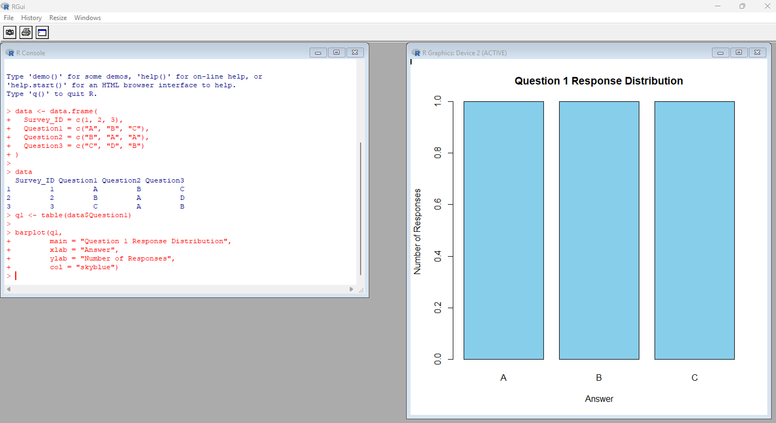

2. Stacked Bar Chart – All Questions
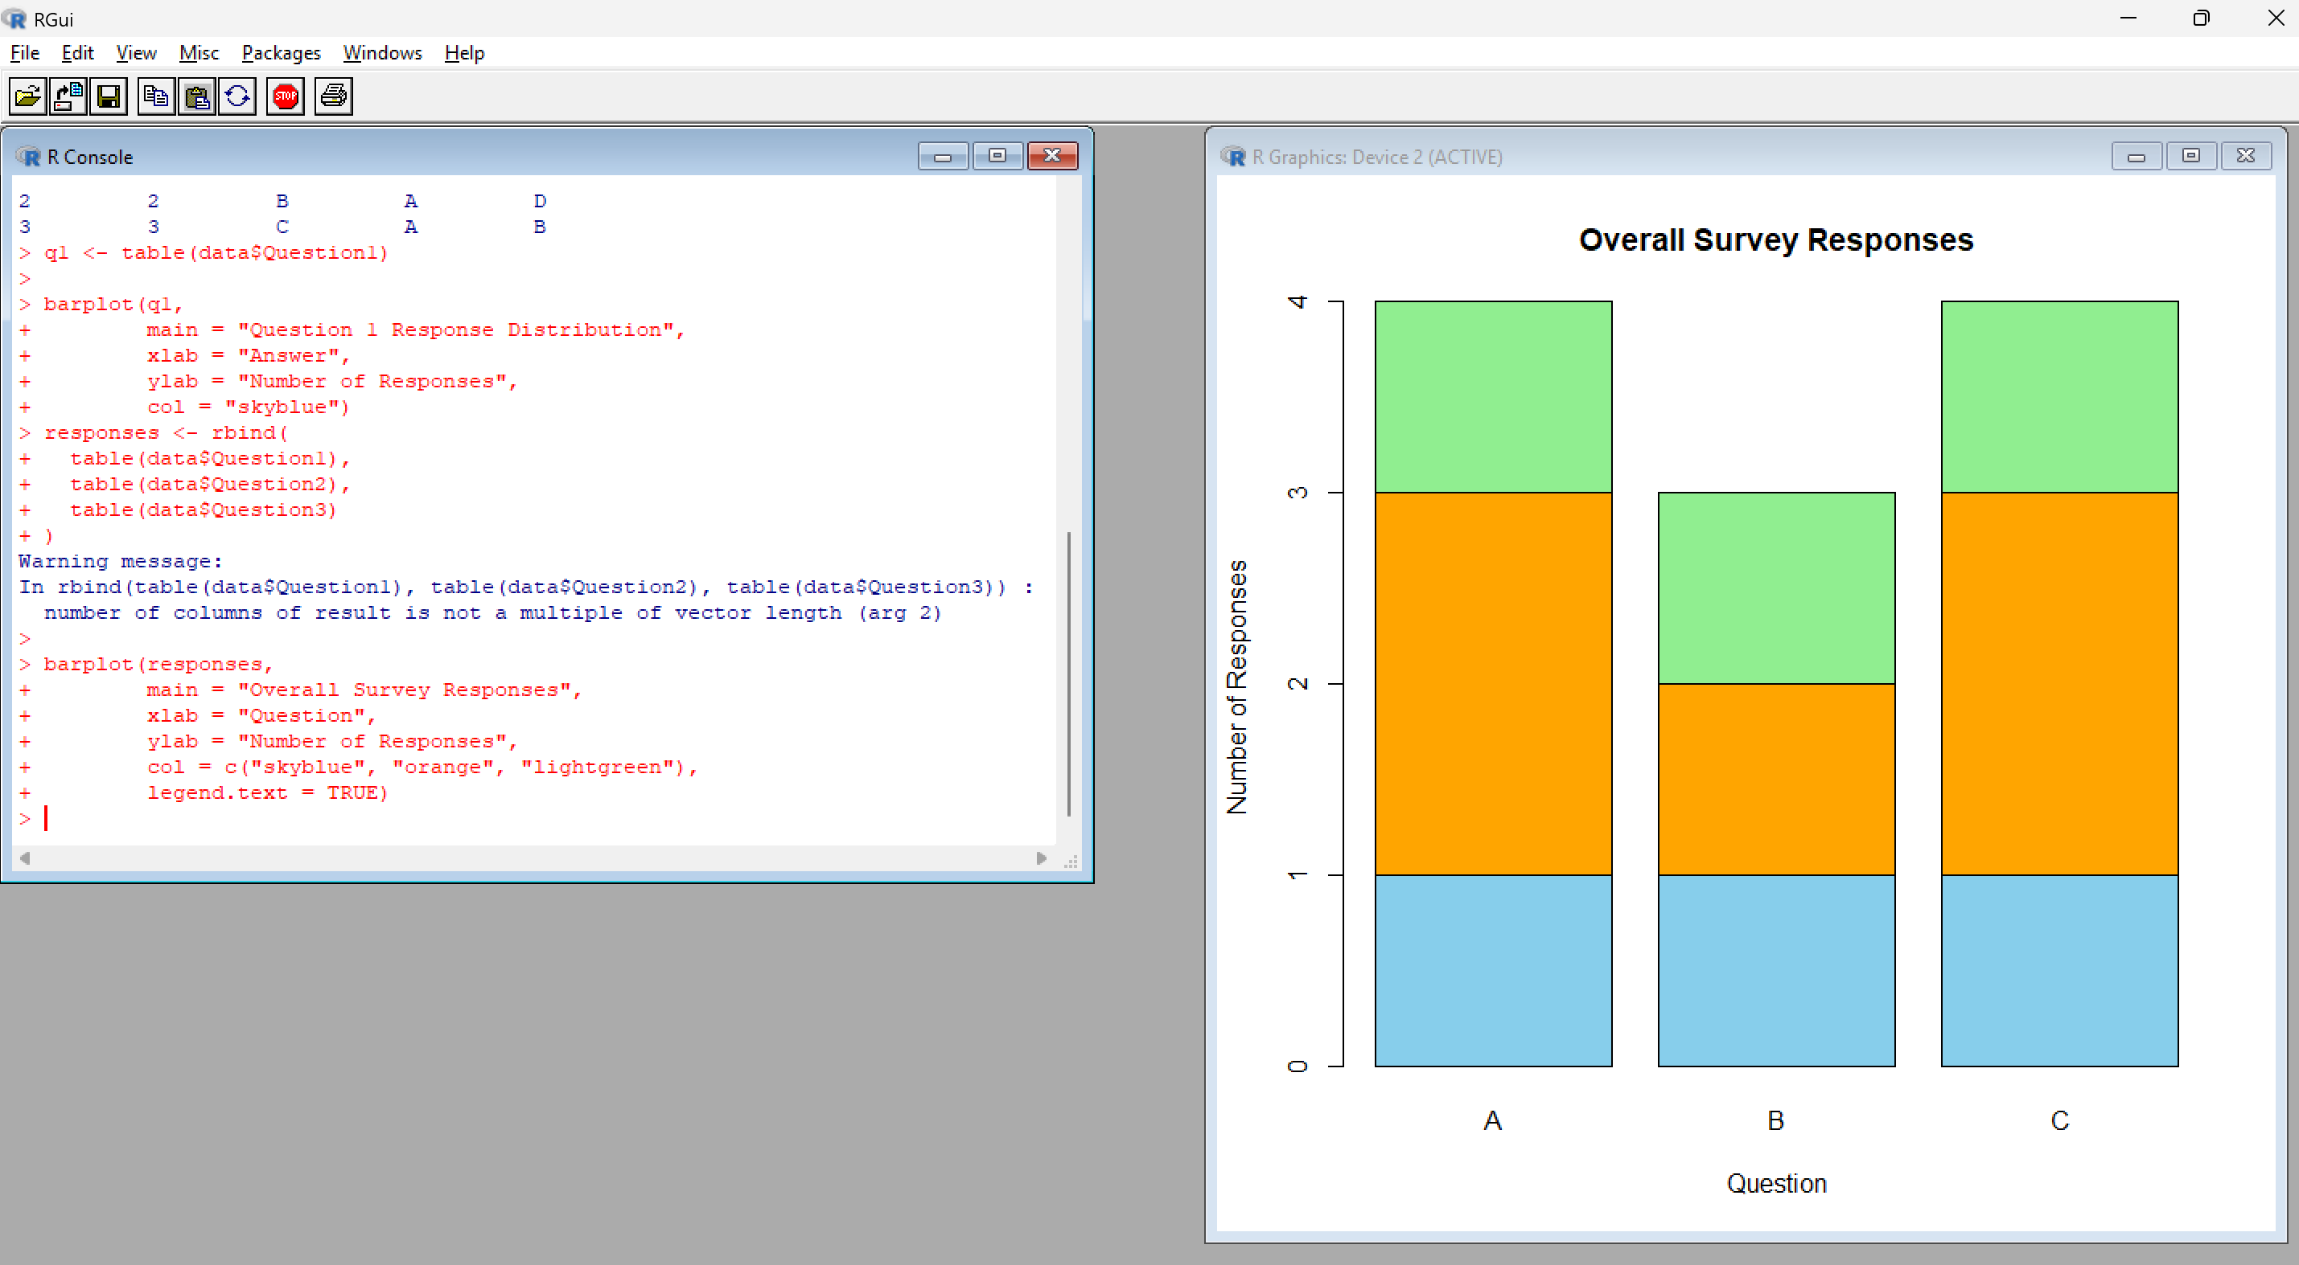

3. Table – Survey Responses
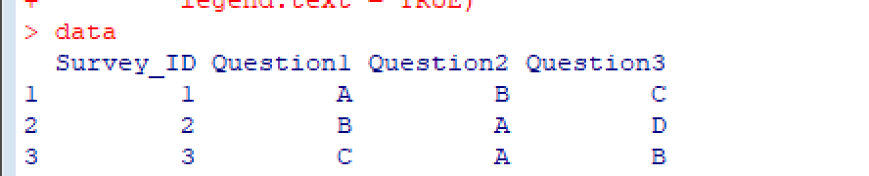

4. TABLEAU DASHBOARD
